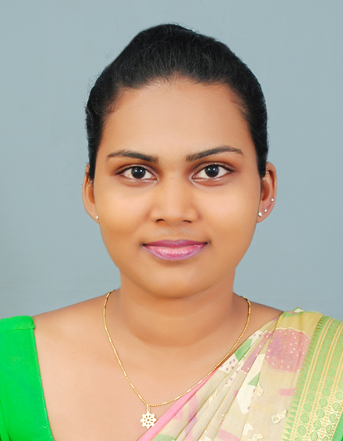
CURRICULUM VITAE
I.M. Uduwalahewa
No: 28/3, Park road, Ratmalana.
Mobile: 0773588584
E mail: maali.sh99@yahoo.com

CAREER OBJECTIVES

“To be a dynamic, professional, working in challenging environment that would enable me to enhance and utilize my skills and abilities in the management and accounting sectors and ventures in to wide range of knowledge, leading to self development and career progression in the field of the same.”

PROFESSIONAL QUALIFICATIONS

- Successfully completed Foundation Level Examination Conducted By the Chartered Accountants of Sri Lanka.
- Presently following Intermediate Level Examination Conducted by the Chartered Accountants of Sri Lanka
WORKING EXPERIENCE

- Working as Assistant Accountant at Dev engineering (Pvt) Ltd from 16th January 2014 to Up to date

- Worked as Assistant Accountant at B.G.Shirke Construction Technology (Pvt) Ltd (Indian Company) from 11th August 2012 to 15th January 2014.
- Handling petty cash & Cheque Payments
- Maintaining All Vouchers & Documents.
- Handling SVAT Documents & other relevant activities of SVAT.
- Preparation of Bank Reconciliations
- Worked as an Account Assistant at Nail Spa (Pvt) Ltd, from 15th February 2012 to 10th August 2012.
- Handling Cash, Petty Cash & Cheque Payments.
- Maintaining All Vouchers & Documents
- Preparation of Salaries, Wages & remittance of EPF& ETF & Commission of staff.
- Updating all Cash Book & Ledger Accounts
- Preparation of Bank Reconciliations.
- Worked as an Accounts & Audit trainee at S W T Associates (Chartered Accountants) from 28th November 2008 to 14th February 2012. Intermediate level Training articles completed.
Handling Cash, Petty Cash & Cheque Payments
Maintaining All Vouchers & Documents
Preparation of Salaries, Wages & remittance of EPF, ETF & PAYE
Preparation of VAT, NBT, ESC & Filling of Returns
Updating all Cash Book & Ledger Accounts
Preparation of Financial Statements
- Bank Reconciliations
- Income Statement, Balance Sheet & Notes
Preparation of Tax Computation & Filling of Returns
EDUCATIONAL QUALIFICATIONS

- Certificate for English Language – British council - (2008)

- G. C. E (ADVANCED LEVEL) EXAMINATION IN 2008
Subjects Grade

Economics C
Business Studies C
Accounts C
General English C

- DHAMMA SCHOOL FINAL CERTIFICATE EXAMINATION-2005

- G. C. E (ORDINARY LEVEL) EXAMINATION IN 2004
Subjects Grade

Sinhala Literature A
Health Science A
Commerce A
Sinhala A
Mathematics B
English B
Buddhism B
Social Studies B
Science C
Dancing C

COMPUTER LITERACY

- Sound knowledge in computerized Accounting Packages
-Quick Book, Peach tree & Tally.
- Familiarized with Microsoft Office Word, Excel,PowePoint
- Familiarized with Internet & E-mail
OTHER SKILLS AND COMPETANCIES
- Ability to write and speak in Sinhala and English

- Excellent in Team work.
- Hard & Dedicated worker.
- Willing to hold the leadership positions and willing take up any challenging position.
EXTRA CURRICULAR ACTIVITIES

- Senior Prefect in school 2006.
- Contribution to the 14th Asian Athletic Championships – 2002
- Played Volley Ball, Net Ball in School team.
- Vice President in School Commerce Society at 2006-2007.
- House Captain in School house meet at 2006

PERSONAL DETAILS

- Name with initials : I M Uduwalahewa
- Full Name : Indika Madushani Uduwalahewa
- Date of Birth :23rd March 1988
- N.I.C. Number : 885831150V
- Sex :Female
- Civil Statues :Single
- Religion :Buddhism
- School Attended :Buddhist Girls’ college – Mt. lavinia.

NON RELATED REFEREES

1. Mr. C G Pathirana 2. Mr. H.I. D. Fernando
Electrical & Services Manager, Director
Shapoorji Pallongi Lanka (Pvt) Ltd, Wigynsa Express (Pvt) Ltd
No. 4, Geethanjali Place , No. 14 A2/1
Colombo 03. Sunethradevi Road, Kohuwala.

Mob: Office : 0753510072 Tele : 0113182073
Personal : 0773335428. Personal : 0767693976

I hereby declare the above information is true and accurate to the best of my knowledge.

I M Uduwalahewa Date

